**জব নংঃ ৩**

**জবের নামঃ জাভাস্ক্রিপ্ট এর বাটন গুলোর কাজ ।**

**তত্ত্ব –** একটি ওপেন সোর্স স্ক্রিপটিং ল্যাঙ্গুয়েজ । এটির দ্বারা যেকোন ওয়েবসাইট বা ওয়েবপেজকে জীবন্ত করা যায় । অর্থাৎ এটির দ্বারা ডাইনামিক ওয়েবসাইট তৈরি করা হয় । এটিকে অনেক সময় ব্রাউজার সাইট ল্যাঙ্গুয়েজ ও বলা হয় ।

**কার্যপ্রণালী -** জাভাস্ক্রিপ্টে onclick ইভেন্টের ব্যবহার –

 Onclick অ্যাট্রিবিউটটি সম্পূর্ণ জাভাস্ক্রিপ্ট। অ্যাট্রিবিউটটি মান হিসেবে একটি ফাংশন নেয় যা বাটনটিতে ক্লিক করা হলে এক্সিকিউট হবে।

* যখন একটি বাটন ক্লিক করা হয় Javascript টি start হয়। coding নিম্নে দেয়া হল-

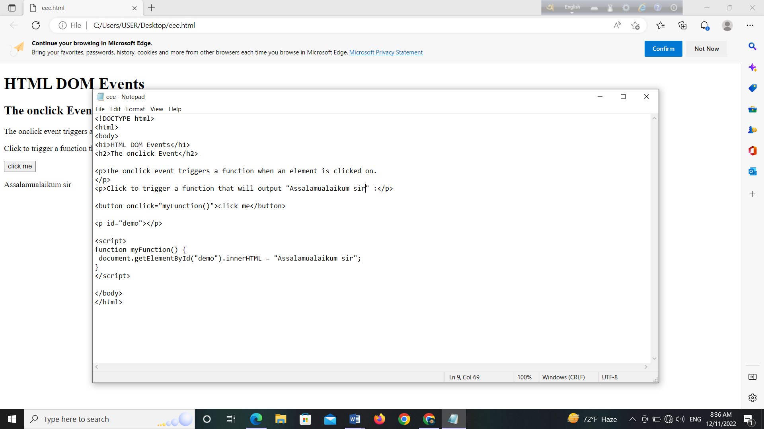

* **output-**

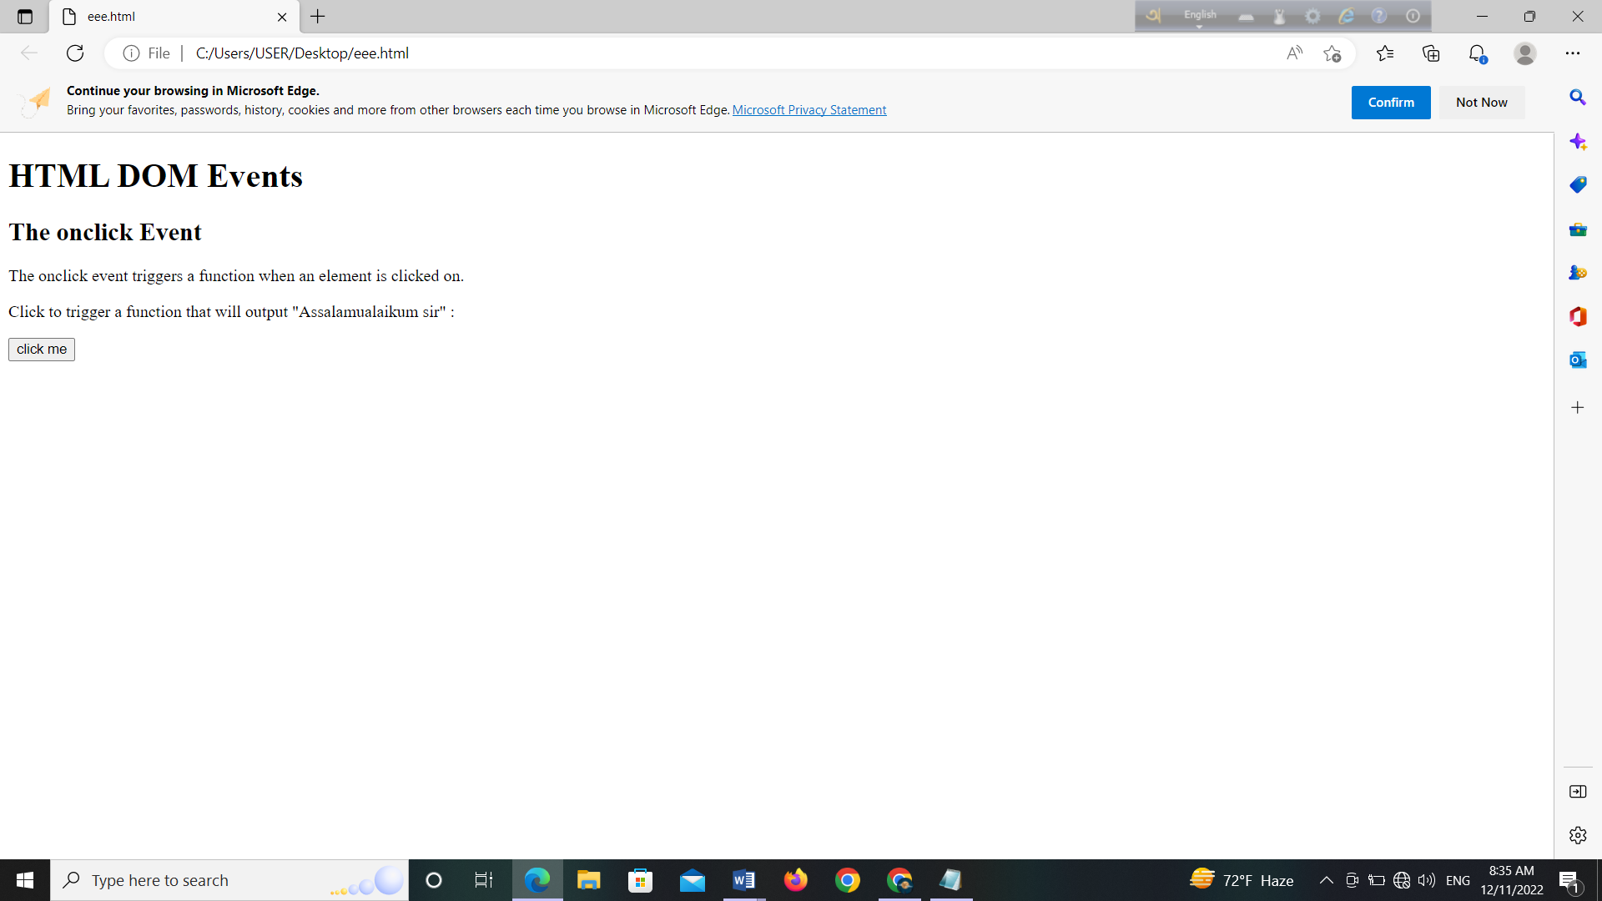

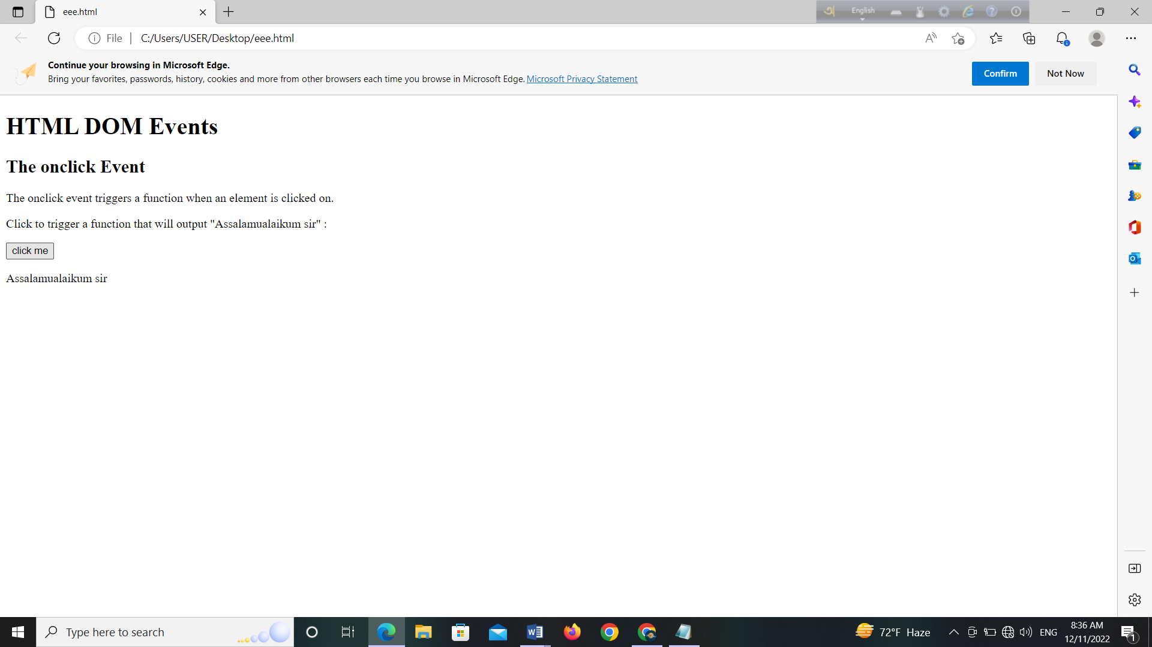

* "onclick" event to the window object:

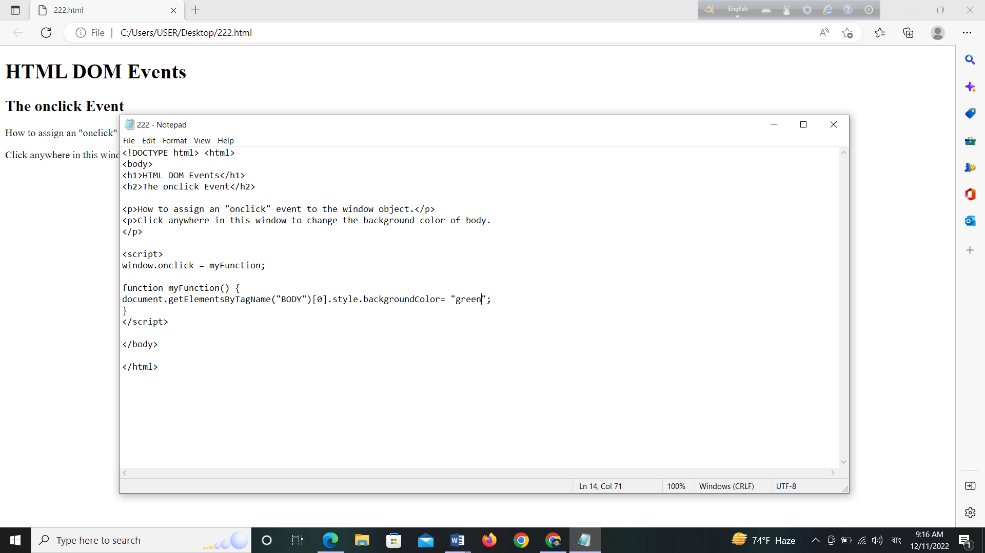

Output -

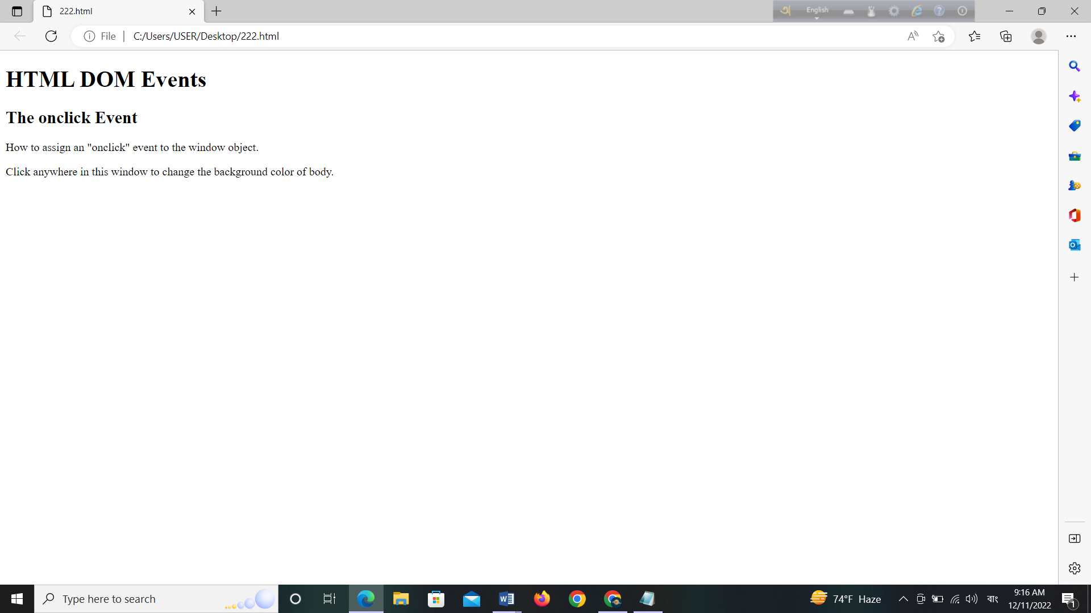

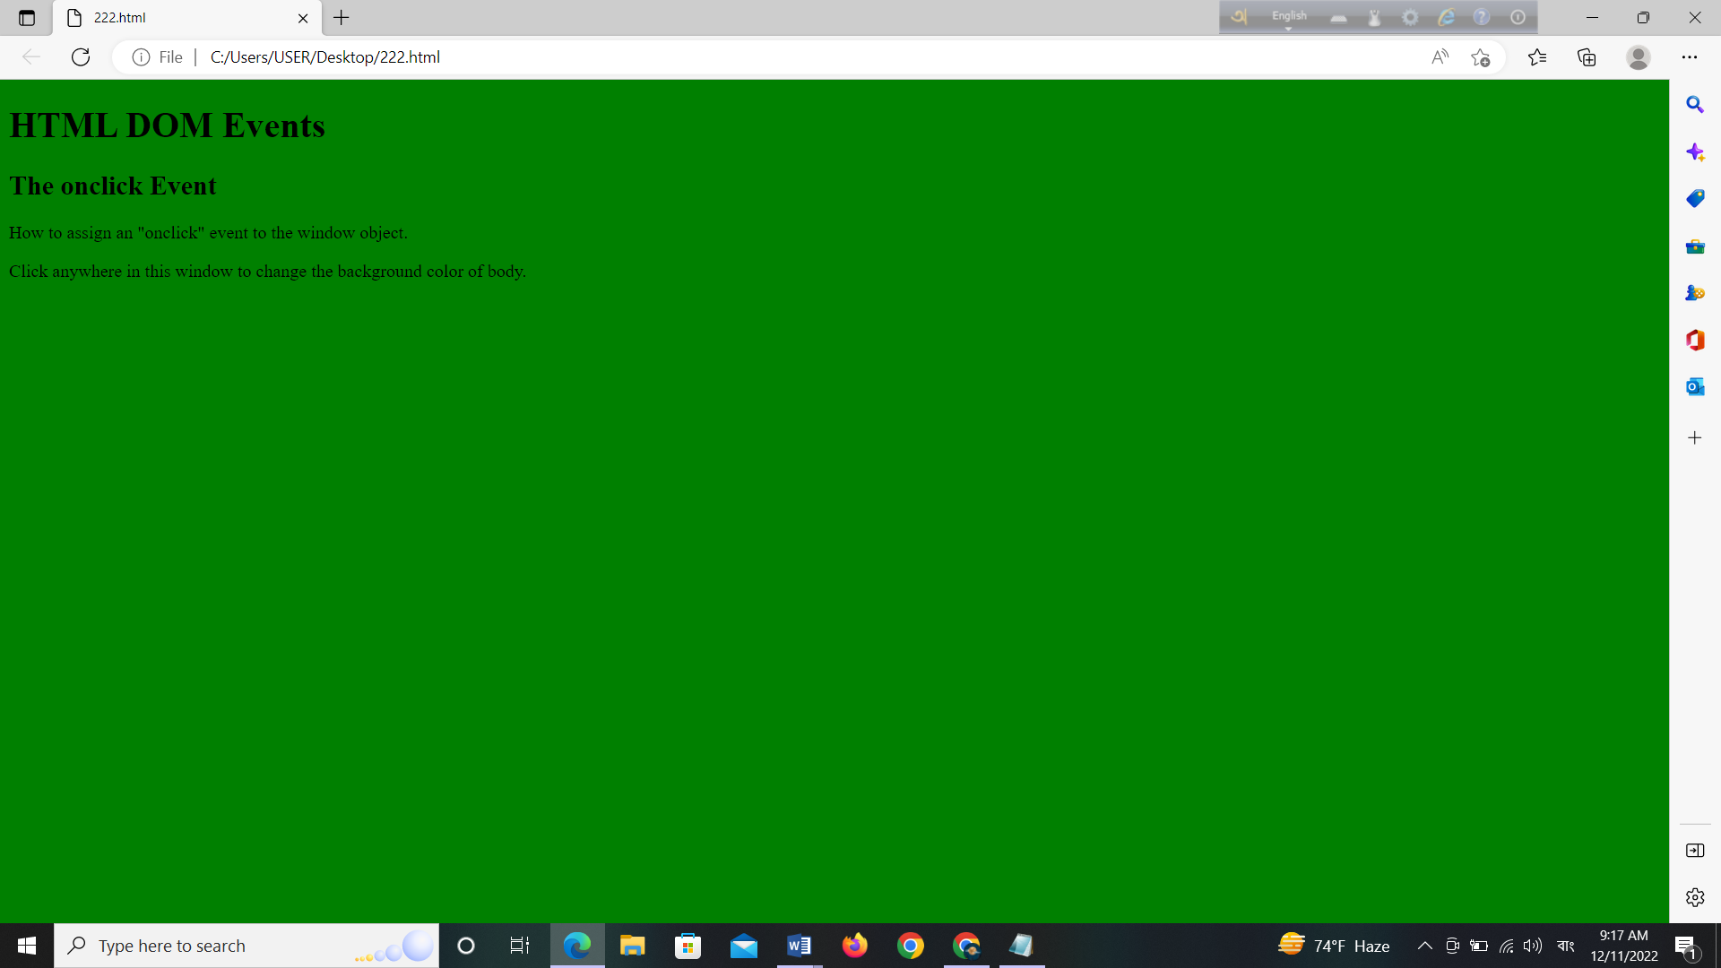

* তারিখ show করার জন্য button ডিসপ্লে করা হল । coding

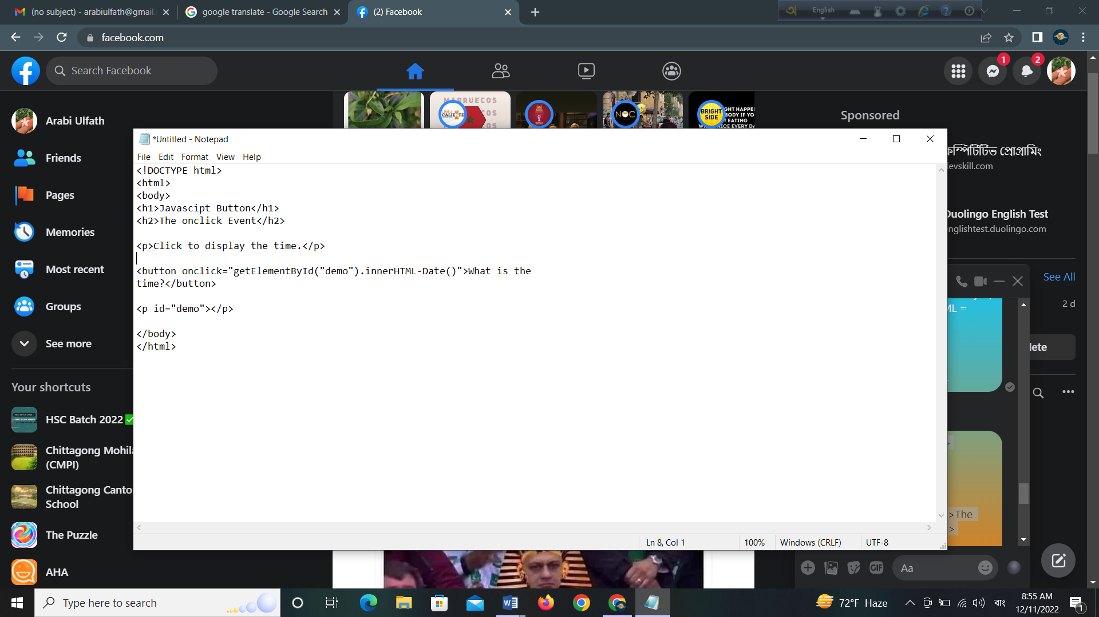

Output-

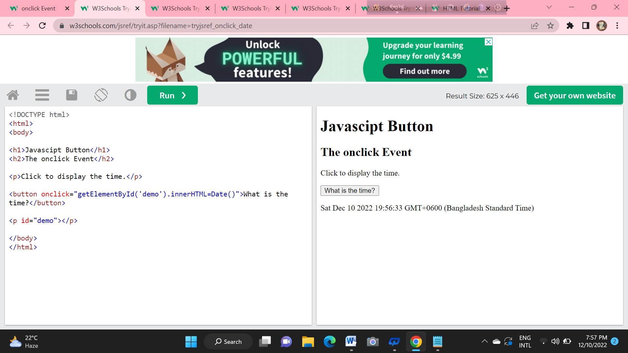

* Click to change the text color:

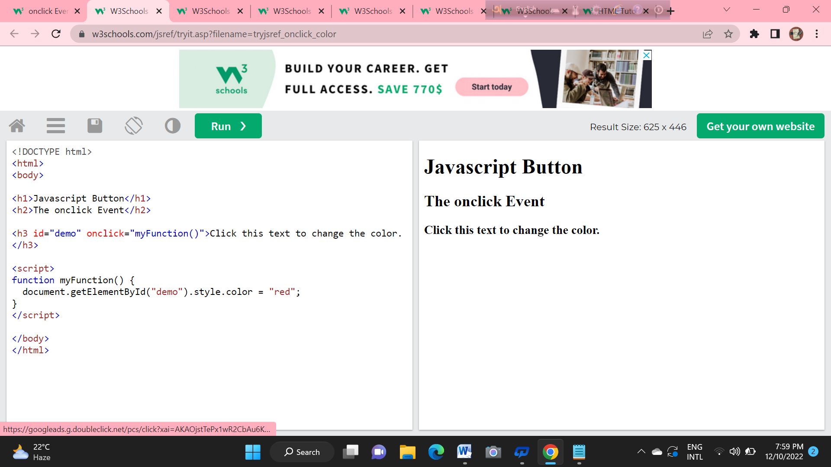

**Output:**

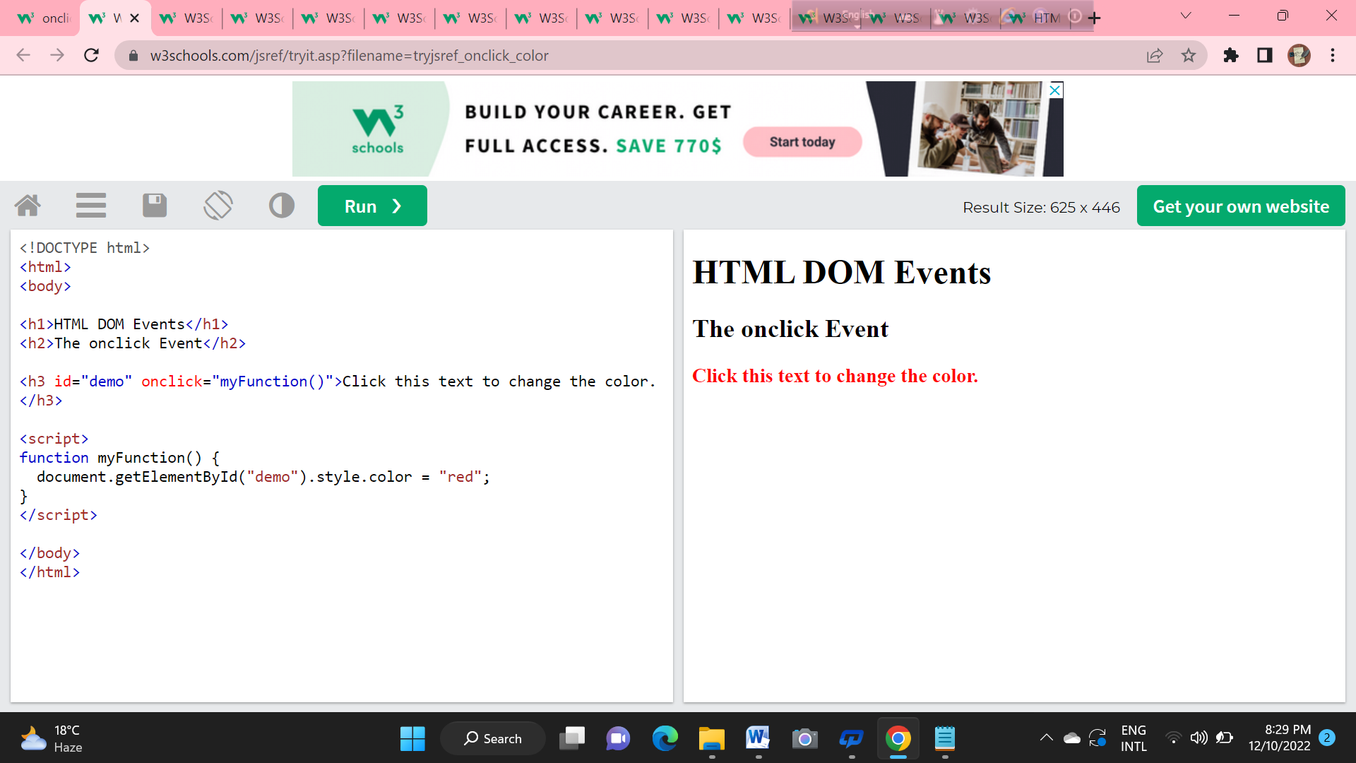

উপরোক্ত এইভাবে আমরা জাভাস্ক্রিপ্ট এর বাটন গুলোর কাজ ।

|  |  |  |  |  |
| --- | --- | --- | --- | --- |
| **CHATTOGRAM MOHILA POLYTECHNIC INSTITUTE**  **Code : 70061**  **North Halishahar,Chittagong-4216**  **Diploma-In-Engineering**  **Department: Computer**  *Experiment No : 01*  *Experiment Name : Functions of buttons in javascript*  *Subject Code : 66643*  *Subject Name : Web Development*  *Date of Experiment :*  *Date of Submission :*   |  |  | | --- | --- | | **Submitted By-** | **Submitted To-** | | ***Name: Pranitka Mutsuddi***  ***Roll:590636***  ***Semester:4 th Shift: 2nd***  ***Session: 20-21*** | ***Rajib Sikdar***  ***Junior Instructor***  ***Dept. of Computer***  ***CMPI,Chattogram-4216*** |   Remarks Teachers Signature |
| **CHATTOGRAM MOHILA POLYTECHNIC INSTITUTE**  **Code : 70061**  **North Halishahar,Chittagong-4216**  **Diploma-In-Engineering**  **Department: Computer**  *Experiment No : 03*  *Experiment Name : Functions of buttons in javascript*  *Subject Code : 66643*  *Subject Name : Web Development*  *Date of Experiment :*  *Date of Submission :*   |  |  | | --- | --- | | **Submitted By-** | **Submitted To-** | | ***Name: Umme Hafsa***  ***Roll:590636***  ***Semester:4 th Shift: 2nd***  ***Session: 20-21*** | ***Rajib Sikdar***  ***Junior Instructor***  ***Dept. of Computer***  ***CMPI,Chattogram-4216*** |   Remarks Teachers Signature |
| **CHATTOGRAM MOHILA POLYTECHNIC INSTITUTE**  **Code : 70061**  **North Halishahar,Chittagong-4216**  **Diploma-In-Engineering**  **Department: Computer**  *Experiment No : 03*  *Experiment Name : Functions of buttons in javascript*  *Subject Code : 66643*  *Subject Name : Web Development*  *Date of Experiment :*  *Date of Submission :*   |  |  | | --- | --- | | **Submitted By-** | **Submitted To-** | | ***Name: Nandini Das***  ***Roll:590646***  ***Semester:4 th Shift: 2nd***  ***Session: 20-21*** | ***Rajib Sikdar***  ***Junior Instructor***  ***Dept. of Computer***  ***CMPI,Chattogram-4216*** |   Remarks Teachers Signature |
| **CHATTOGRAM MOHILA POLYTECHNIC INSTITUTE**  **Code : 70061**  **North Halishahar,Chittagong-4216**  **Diploma-In-Engineering**  **Department: Computer**  *Experiment No : 03*  *Experiment Name : Functions of buttons in javascript*  *Subject Code : 66643*  *Subject Name : Web Development*  *Date of Experiment :*  *Date of Submission :*   |  |  | | --- | --- | | **Submitted By-** | **Submitted To-** | | ***Name: Fatema Akter Ebadi***  ***Roll:590607***  ***Semester:4 th Shift: 2nd***  ***Session: 20-21*** | ***Rajib Sikdar***  ***Junior Instructor***  ***Dept. of Computer***  ***CMPI,Chattogram-4216*** |   Remarks Teachers Signature |
| **CHATTOGRAM MOHILA POLYTECHNIC INSTITUTE**  **Code : 70061**  **North Halishahar,Chittagong-4216**  **Diploma-In-Engineering**  **Department: Computer**  *Experiment No : 03*  *Experiment Name : Functions of buttons in javascript*  *Subject Code : 66643*  *Subject Name : Web Development*  *Date of Experiment :*  *Date of Submission :*   |  |  | | --- | --- | | **Submitted By-** | **Submitted To-** | | ***Name: Amena Akter Tugni***  ***Roll:590643***  ***Semester:4 th Shift: 2nd***  ***Session: 20-21*** | ***Rajib Sikdar***  ***Junior Instructor***  ***Dept. of Computer***  ***CMPI,Chattogram-4216*** |   Remarks Teachers Signature |
| **CHATTOGRAM MOHILA POLYTECHNIC INSTITUTE**  **Code : 70061**  **North Halishahar,Chittagong-4216**  **Diploma-In-Engineering**  **Department: Computer**  *Experiment No : 03*  *Experiment Name : Functions of buttons in javascript*  *Subject Code : 66643*  *Subject Name : Web Development*  *Date of Experiment :*  *Date of Submission :*   |  |  | | --- | --- | | **Submitted By-** | **Submitted To-** | | ***Name: Arabi Ulfath***  ***Roll:590631***  ***Semester:4 th Shift: 2nd***  ***Session: 20-21*** | ***Rajib Sikdar***  ***Junior Instructor***  ***Dept. of Computer***  ***CMPI,Chattogram-4216*** |   Remarks Teachers Signature |
| **CHATTOGRAM MOHILA POLYTECHNIC INSTITUTE**  **Code : 70061**  **North Halishahar,Chittagong-4216**  **Diploma-In-Engineering**  **Department: Computer**  *Experiment No : 03*  *Experiment Name : Functions of buttons in javascript*  *Subject Code : 66643*  *Subject Name : Web Development*  *Date of Experiment :*  *Date of Submission :*   |  |  | | --- | --- | | **Submitted By-** | **Submitted To-** | | ***Name: Saida Anjum Moniha***  ***Roll:590615***  ***Semester:4 th Shift: 2nd***  ***Session: 20-21*** | ***Rajib Sikdar***  ***Junior Instructor***  ***Dept. of Computer***  ***CMPI,Chattogram-4216*** |   Remarks Teachers Signature |